**ELECTRIC VEHICLE MARKET SEGMENTATION ANALYSIS**

By Deepti Agarwal

[Github Link](https://github.com/DeeptiAgarwal16/FeyNN-Labs/tree/main/3.%20EV%20Market%20Segmentation)

**Abstract**

*This project presents a comprehensive analysis of India's electric vehicle market, focusing on segmentation derived from sales data, customer reviews, and technical specifications. The study highlights the robust growth trajectory of India's two-wheeler market, establishing it as a primary revenue source. Utilizing behavioral variables from customer reviews, a rigorous market segmentation analysis was conducted employing the standard k-means algorithm. The analysis effectively partitioned the market into four distinct segments.*

*Segment 1 emerges as the cornerstone of our strategy, constituting a substantial 39% of the consumer base. This segment not only represents a substantial market opportunity but also serves as the optimal target for our venture. The analysis guides the recommendation of specific electric two-wheeler technical specifications tailored to meet the preferences of Segment 1 consumers.*

*The recommended specifications, seamlessly integrating with the demands of this segment, are pivotal to our approach. Moreover, the price range aligns closely with the median values, ensuring affordability and competitiveness. This strategic alignment with Segment 1, identified as the potential early market customer base, positions our venture optimally within India's electric vehicle landscape.*

1. **Introduction**

India's transportation sector is undergoing a profound transformation with the growing adoption of Electric Vehicles (EVs). The country's rapid urban development, rising population, and increasing income levels have accelerated the shift towards EVs as a greener alternative. Electric two-wheelers, in particular, have become prominent due to their cost-effectiveness and broad appeal. These vehicles are significantly altering India's mobility patterns by providing an eco-friendly solution to pollution and reducing greenhouse gas emissions.

The Indian government has been instrumental in promoting this transition by introducing policies that support local manufacturing and establishing a comprehensive network of manufacturers, dealers, and service providers. By 2023, the electric two-wheeler market in India has reached a significant milestone, reflecting the success of these initiatives and the growing popularity of clean transportation options.

This analysis focuses on this transformative period, examining the electric vehicle market with an emphasis on two-wheelers. By integrating behavioral and psychographic data with detailed vehicle specifications, we offer well-informed recommendations for EV pricing. This comprehensive approach is designed to benefit consumers, policymakers, and industry stakeholders. It aims to provide insights into consumer behavior and preferences, guiding the development of a sustainable and user-focused electric transportation system in India.

1. **Problem Overview and Estimation Approach**
   1. **Problem Statement**

The primary objective is to strategically position our Electric Vehicle Startup within the Indian market by leveraging data-driven insights from various sources. This includes analyzing sales figures, customer feedback (which covers behavioral and psychographic aspects), and technical specifications of electric vehicles. We aim to use these insights to segment the market effectively and identify the most promising target segments for our electric vehicles.

* 1. **Analytical Approach**
     1. **Data Gathering and Evaluation**
* Collect data on sales, customer reviews for electric vehicles, and technical specifications.
* Assess the quality and completeness of the collected data to ensure reliability.
  + 1. **Market Segmentation via Behavioral Insights**
* Analyze behavioral data to uncover patterns and segment the customer base.
* Determine the size and attributes of each segment using analytical methods.
  + 1. **Psychographic Analysis**
* Examine psychographic data within each behavioral segment to understand customer preferences and motivations.
* Identify and estimate the psychographic characteristics of customers in each segment.
  + 1. **Evaluation of Technical Features and Pricing**
* Assess the technical specifications of electric vehicles for each identified segment.
* Evaluate how technical features and pricing influence customer preferences and buying decisions.
  + 1. **Selection of Target Segments**
* Choose target segments based on a detailed analysis of behavioral, psychographic, and technical factors.
  + 1. **Tailoring the Marketing Strategy**
* Create a customized marketing mix for the selected target segments.
* Analyze the effectiveness of different marketing strategies within these segments to ensure alignment with customer preferences.
  + 1. **Final Segment Recommendations**
* Synthesize segment analysis and marketing mix adjustments to make final recommendations.
* Identify and recommend the segments with the greatest market potential for a focused market entry strategy.

By following these structured steps, our Electric Vehicle Startup will utilize data-driven insights to accurately identify and target market segments, enabling us to align our marketing strategy with customer needs and drive successful market entry and growth.

1. **Data Collection**

For this project, data was sourced from three distinct origins. The first dataset, provided by the Society of Manufacturers of Electric Vehicles, covers sales data from 2017 to 2023, detailing figures for electric two-wheelers, three-wheelers, four-wheelers, and buses. This comprehensive dataset offers insights into market trends and customer preferences over time.

The second dataset, gathered from bikewale.com, includes customer reviews for electric two-wheelers, which offer crucial behavioral and psychographic insights. These qualitative data points are essential for understanding customer behavior.

The third dataset, also from bikewale.com, features technical specifications and pricing information for electric two-wheelers. This data is instrumental in evaluating the technical feasibility and pricing strategies necessary for effective market segmentation.

By synthesizing these datasets, we developed a thorough understanding of the electric vehicle market. The combination of real sales data, customer feedback, and technical details provided a solid foundation for a data-driven and market-relevant segmentation strategy.

1. **Data Pre-processing**

The data pre-processing phase of this project followed a structured methodology, leveraging Python libraries such as numpy, pandas, matplotlib, seaborn, and nltk. The initial step involved managing the sales data, which was distributed across 10 separate Excel sheets. By employing pandas, these sheets were consolidated into a single dataset, creating a solid foundation for further analysis. Special attention was given to ensuring the accuracy of electric vehicle manufacturer names through careful data cleaning processes.

After merging the data, critical aggregation operations were carried out on the electric two-wheeler sales data, offering a comprehensive view of market trends. The next stage focused on preparing the data for market segmentation. Customer reviews were integrated with the relevant technical specifications of electric vehicles. To maintain data accuracy, null values were addressed with appropriate logical values, resulting in a complete dataset.

Sentiment analysis of customer reviews was performed using nltk’s natural language processing tools. This analysis yielded valuable qualitative insights into customer sentiments. Following this, behavioral variables such as Visual Appeal, Reliability, Performance, Service Experience, Extra Features, Comfort, Maintenance Cost, and Value for Money were carefully isolated and prepared. These variables were crucial for the market segmentation analysis, providing a detailed understanding of customer preferences and attitudes towards electric vehicles.

1. **Segment Extraction**
   1. **Utilizing Sales Data**

This section presents an in-depth analysis based on three key metrics from India's electric vehicle market. The analysis focuses on understanding market dynamics and consumer behavior by examining these crucial figures.

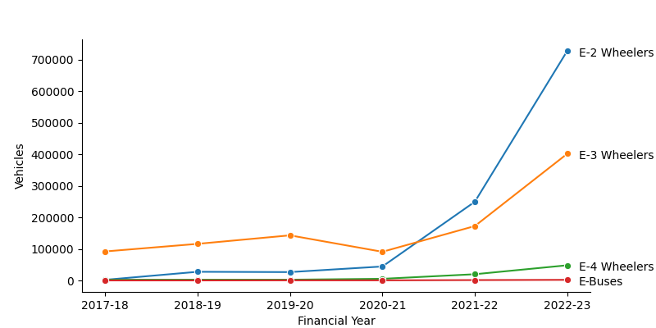

**Figure 5.1 India’s electric vehicle market**

Figure 5.1 showcased the remarkable growth trajectory of India's two-wheeler market in 2023, underscoring its leading position within the industry.

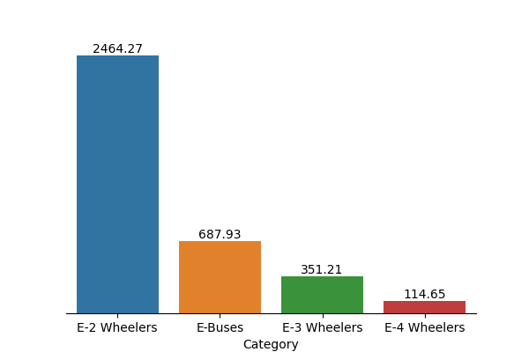

**Figure 5.2 India’s electric vehicle industry in crores**

Figure 5.2 explored the financial landscape of the electric vehicle market, showcasing the industry's total valuation in crores. It was observed that two-wheelers are the predominant contributors to revenue, underscoring their economic importance in the sector.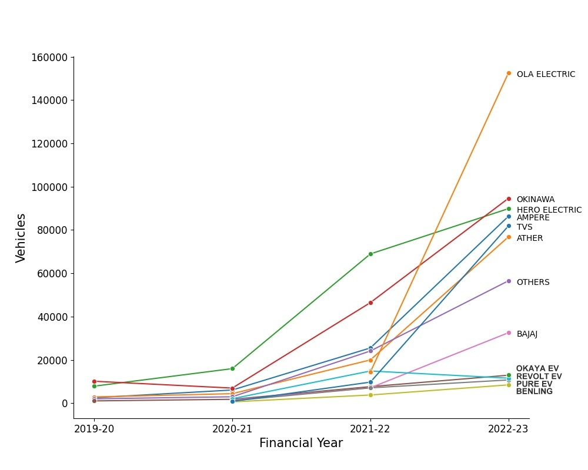

**Figure 5.3 Top electric two-wheeler companies**

Figure 5.3 focused on key electric two-wheeler companies, highlighting Ola Electric as the market leader in 2023. This demonstrated Ola Electric's prominent position and competitive edge within the industry.

The analysis of these figures clearly indicated that the electric two-wheeler segment represented the most promising area for further investigation. The significant growth, revenue contribution, and market leadership of this segment underscored its importance and potential, making it the ideal candidate for our detailed study.

* 1. **Market Segmentation Using k-Means**

In the next phase of analysis, the k-means clustering algorithm was employed to explore potential market segments within the electric two-wheeler customer reviews data. The analysis tested solutions for segment numbers ranging from two to eight. The decision-making process was guided by the scree plot in Figure 5.4, which revealed a clear elbow at four segments. This point marked a notable reduction in within-cluster distances, indicating the optimal number of segments for our study.

By integrating insights from these analyses, our focus was maintained on the electric two-wheeler segment, ensuring that our market segmentation approach was both precise and relevant.

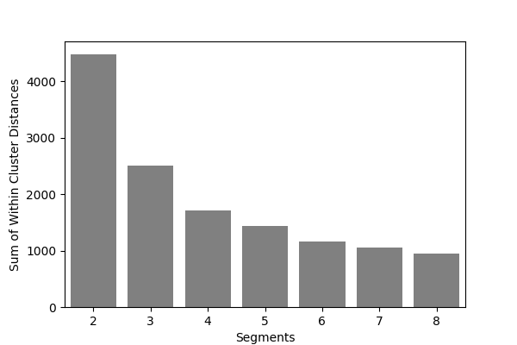

**Figure 5.4 Scree plot for the electric vehicle data set**

1. **Profiling and Describing Segmentation**
   1. **Segment Profiling**

This section provides an in-depth analysis of the identified consumer segments, as depicted in Figure 6.1. The figure illustrates the varied perceptions across different segments.

* **Segment 0:** Comprising 15% of consumers, this group places high importance on the visual appeal, reliability, performance, service experience, and comfort of electric two-wheelers.
* **Segment 1:** Representing 39% of consumers, this segment shows dissatisfaction across all evaluated aspects. Despite being the largest segment, it is also the least satisfied, highlighting a critical area for improvement.
* **Segment 2:** Making up 33% of consumers, this group values visual appeal, reliability, service experience, and comfort, with a notable emphasis on perceived value for money.
* **Segment 3:** The smallest segment at 13%, values visual appeal, reliability, performance, service experience, extra features, and maintenance cost. This segment demonstrates distinct preferences, particularly in terms of features and cost considerations.

These profiles provide a nuanced understanding of consumer attitudes and preferences, offering valuable insights for targeted strategies and improvements.

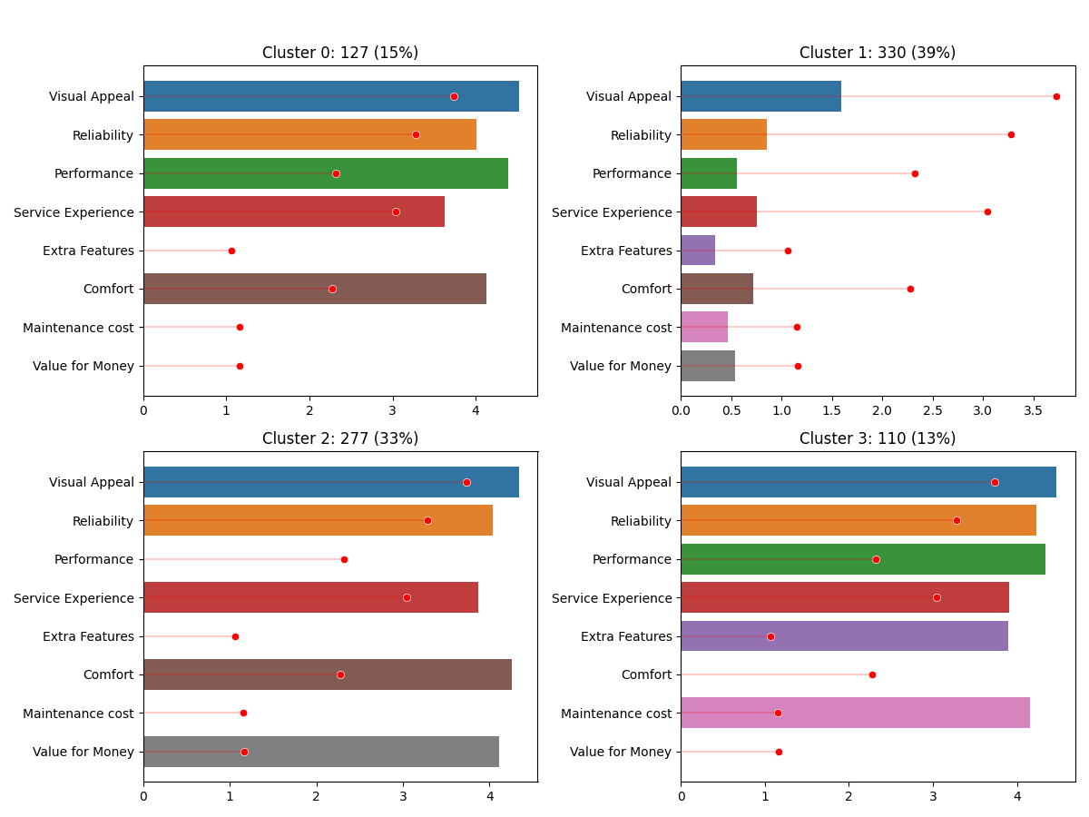

**Figure 6.1 Segment profile plot for the four-segment solution**

Figure 6.2 utilizes principal component analysis to further highlight the distinctions between consumer segments. It reveals that Segment 1, despite being the largest group, exhibits a notable absence of strong opinions, distinguishing them by their general dissatisfaction.

These insights are crucial for developing targeted strategies. Understanding these diverse consumer perceptions allows us to tailor our electric vehicle offerings to better align with the varied values and priorities of each segment, ultimately enhancing market fit and customer satisfaction.

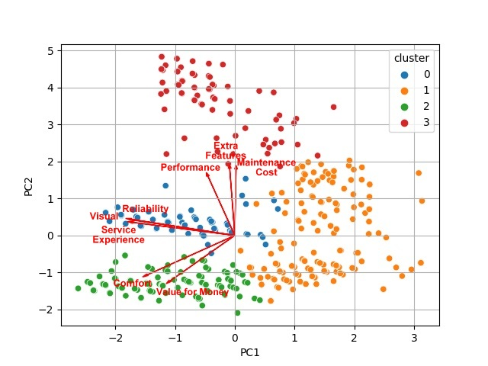

**Figure 6.2 Segment separation plot using principal components 1 and 2**

* 1. **Describing Segments**

Figure 6.3 depicts the primary use of electric vehicles across segments. The mosaic plot indicates that all segments predominantly utilize their electric vehicles for daily commuting. Usage for tours, occasional commuting, and leisure rides remains relatively limited across all groups.

Figure 6.4 provides insights into the duration of electric vehicle ownership among segments. Segment 1 stands out for having the longest ownership period, with members having owned their vehicles for over a year. In contrast, Segment 0 is characterized by a lack of prior ownership experience. Segment 2 shows a range of ownership durations, from less than 3 months to over a year, while Segment 3 includes individuals who have owned their vehicles for just a few days to less than 3 months.

These visualizations and ownership patterns provide a deeper understanding of how different segments interact with electric vehicles, informing strategic decisions on product development, marketing, and customer engagement.

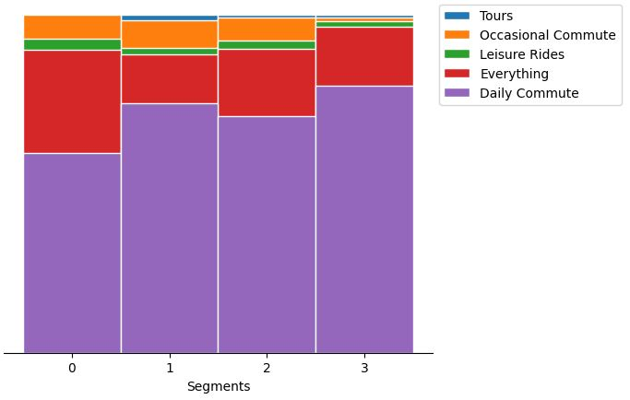

**Figure 6.3 Mosaic plot showcasing electric vehicle usage patterns across segments**

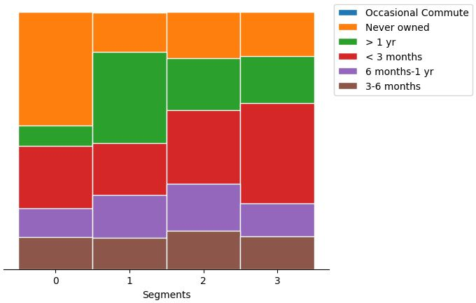

**Figure 6.4 Mosaic plot depicting the ownership duration of electric vehicles across segments**

Figure 6.5 delves into the distances covered by consumers, indicating that all segments predominantly use electric vehicles for commuting, with most users covering distances below 5000 kms. A small portion falls in the 5000 to 10000 kms range, aligning with their commuting needs.

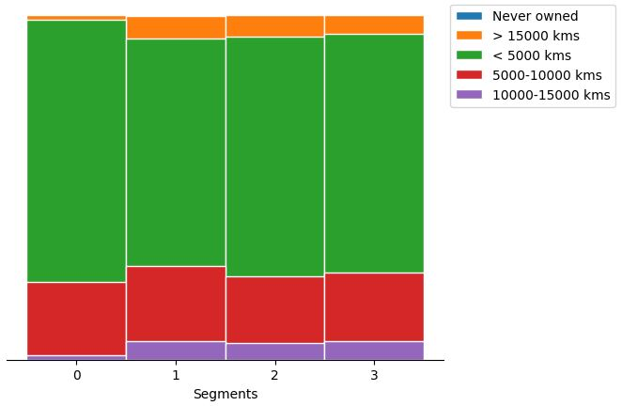

**Figure 6.5 Mosaic plot outlining consumers distance covered by consumers on electric vehicles**

Figure 6.6 explores consumer sentiments, revealing that all segments, except Segment 1, exhibit positive sentiments. Segment 1 consumers stand out with negative sentiments, indicating dissatisfaction across various aspects.

Figure 6.7, a parallel box and whisker plot, emphasizes significant differences in average ratings among segments. Specifically, Segment 1 consumers express dissatisfaction across all perceptions, leading to lower overall ratings. These graphical representations offer nuanced insights into consumer behaviors, sentiments, and preferences, guiding our strategic decisions for a more tailored approach in the electric vehicle market.

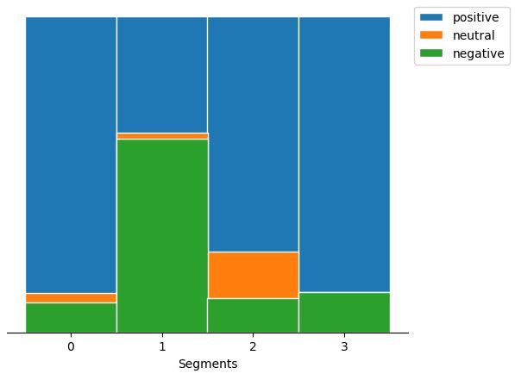

**Figure 6.6 Mosaic plot displaying consumer sentiments towards electric vehicles**

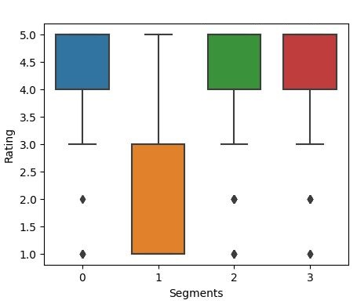

**Figure 6.7 Parallel box-and-whisker plot showcasing consumer ratings across segments**

* 1. **Analyzing Technical Specifications Across Segments**

The examination of technical specifications reveals distinct preferences among the segments, with each group exhibiting unique priorities in their choice of electric vehicles.

Figure 6.8 (a) presents a parallel box and whisker plot illustrating the price ranges across segments. Segment 0 demonstrates a preference for higher-priced, premium electric vehicles, indicating a willingness to invest in high-end models. Conversely, Segment 1 shows a preference for budget-friendly options, reflected in a lower price range. Segments 2 and 3 also prioritize affordability but with slight variations, underscoring diverse economic considerations.

Figure 6.8 (b) highlights the average riding range for each segment. Segment 0 stands out with a higher average riding range, indicating a preference for vehicles that can travel longer distances. In contrast, Segment 1 and Segment 2 focus on moderate ranges suitable for daily commuting, while Segment 3 caters to consumers who require slightly longer ranges, addressing specific commuting needs.

Figure 6.8 (c) illustrates preferences regarding top speed. Segments 0 and 3 favor electric vehicles with higher top speeds, reflecting a preference for performance-oriented models. On the other hand, Segment 1 and Segment 2 prioritize lower speeds, suitable for city commuting, highlighting a focus on practical, everyday use.

Figure 6.8 (d) examines vehicle weight preferences. Segment 0 and Segment 1 show a preference for slightly heavier vehicles, which may contribute to stability and durability. In contrast, Segments 2 and 3 lean towards lighter vehicles, catering to preferences for ease of maneuverability and efficiency.

Figure 6.8 (e) depicts battery charging times. Segment 0 and Segment 3 are inclined towards slightly longer charging durations, which suggests an acceptance of overnight charging. Meanwhile, Segment 1 and Segment 2 prioritize faster charging options, reflecting a need for quicker turnaround times to accommodate busy lifestyles.

These technical specifications provide a detailed understanding of segment-specific preferences, shaping the strategic approach for targeting and meeting the diverse needs of electric vehicle consumers in India.

|  |  |
| --- | --- |
| (a) | (b) |
| (c) | (d) |
| (e) | (f) |

**Figure 6.8. Parallel box-and-whisker plot of technical specification of electric vehicle by segment**

1. **Target Segment Selection**

In determining the ideal target segments for our electric vehicle market strategy, Segment 1 and Segment 2 emerge as key focal points. Segment 1, which constitutes 39% of the consumer base, represents a substantial market segment with varied perceptions and preferences. This segment's diverse sentiments reveal specific demands and areas for improvement. Addressing their dissatisfaction directly could enhance customer satisfaction and foster brand loyalty within this large segment.

Segment 2, comprising 33% of consumers, offers a valuable opportunity due to their clear preferences for visual appeal, reliability, service experience, and comfort. By tailoring our electric vehicles to these specific desires, we can better align our products with their expectations and create a stronger market presence. Segment 2’s feedback, emphasizing value for money, can guide us in refining our offerings to meet their needs effectively.

Overall, Segment 1 provides both a challenge and an opportunity. By addressing their dissatisfaction and improving product features, we can achieve substantial market impact. At the same time, enhancing features that Segment 2 values will ensure a positive customer experience and reinforce brand loyalty. Our strategy will thus focus on refining product features, addressing dissatisfaction, and enhancing positive attributes to meet the unique needs of these segments, ensuring competitive advantage and sustained growth.

1. **Marketing Mix Customization**

To effectively engage with Segment 1 and Segment 2, our marketing mix must be meticulously tailored. For Product Customization, we will enhance features based on the specific needs of each segment. For Segment 1, this means addressing concerns about performance and service experience, while for Segment 2, we will emphasize visual appeal and value for money. A diverse product range within each segment will cater to varying tastes and budgets.

Price Customization involves setting competitive pricing strategies. Segment 1 will benefit from affordable pricing options, while Segment 2 may accept a higher price for added features.

Promotion Customization will focus on targeted advertising. For Segment 1, the emphasis will be on reliability and service improvements, while Segment 2 will be targeted with campaigns highlighting aesthetics and affordability. Promotional events and online campaigns will be tailored to engage each segment effectively.

Place Customization will involve establishing accessible distribution channels. Segment 1 will have distribution focused on urban areas, while Segment 2 will be targeted in suburban and semi-urban regions. A strong online presence, including virtual showrooms and customer support platforms, will enhance the purchasing experience.

People and Process Customization includes training customer service representatives to address specific segment concerns empathetically. Streamlined processes for customization requests and service appointments will improve customer satisfaction and loyalty.

By aligning our marketing mix with the distinct needs of Segment 1 and Segment 2, we ensure our electric vehicles resonate with these segments, fostering market relevance and customer preference.

1. **Estimating Potential Early Market**

Analyzing the potential early market customer base reveals two primary segments: Segment 1 with 330 members (39% of consumers) and Segment 2 with 277 members (33% of consumers). Based on price range data, the optimal target price for Segment 1 is between ₹51,094 and ₹1,67,844, and for Segment 2, between ₹51,094 and ₹1,37,890.

Calculations of potential sales profit involve multiplying the number of potential customers in each segment by the targeted price range. For a target price of ₹1,20,000 in Segment 1, the estimated profit is ₹39.60 crores. For Segment 2, with a target price of ₹1,10,000, the potential profit is ₹30.47 crores.

Segment 1 offers greater market potential due to its larger customer base and higher market share, making it a primary focus for initial market entry. These profit estimates highlight substantial market opportunities within these segments, guiding strategic decisions.

1. **Optimal Market Segment**

After thorough analysis, Segment 1 is identified as the most optimal market segment for our electric two-wheeler vehicles. With 39% of the consumer base, this segment offers significant opportunities and a large potential customer base, making it ideal for market penetration. Its substantial market potential, combined with favorable technical specifications and price range, positions Segment 1 as the most promising target for our electric vehicles.

The recommended technical specifications for Segment 1, detailed in Table 10.1, ensure our offerings align with the diverse needs and preferences of this segment, maximizing market impact.

|  |  |
| --- | --- |
| **Specification** | **Recommended Range (in INR)** |
| Price | 70,688 – 1,29,063 |
| Riding range | 89 - 180 km |
| Top speed | 58 - 116 kmph |
| Weight | 76 - 120 kg |
| Battery charging time | 3 - 5 hours |
| Rated power | 1200 - 5500 W |

**Table 10.1 Technical specification of electric vehicle two-wheeler for segment 1**

This comprehensive analysis ensures our market entry strategy is finely tuned to cater to the demands and expectations of the chosen segment, setting the stage for a successful and sustainable venture into the electric vehicle market.

1. **Conclusion**

Our comprehensive analysis of India's electric vehicle market has pinpointed Segment 1 as the prime target for our electric two-wheelers. With 39% of the consumer base, this segment offers substantial market potential. By customizing our vehicle specifications to align with the preferences and needs of this segment, we can cater to a significant portion of the market effectively.

This strategic choice is backed by a detailed understanding of market segmentation, consumer behavior, and technical specifications. The insights gained from this analysis provide a clear direction for our market entry, emphasizing precision and relevance in both product development and marketing strategies.

By focusing on Segment 1, we are well-positioned to make a significant impact in India's electric vehicle market. This approach ensures that our offerings resonate with a large customer base, establishing a solid foundation for success in the evolving landscape of electric mobility in India.

**References**

* Society of Manufacturers of Electric Vehicles. (2023, October). Retrieved from [SMEV](https://www.smev.in/ev-industry)
* Bikewale. (2023, October). Retrieved from [Bikewale](https://www.bikewale.com/)
* Dolnicar, S., Grün, B., & Leisch, F. (2018). *Market Segmentation Analysis*. Springer Open, Management for Professionals.